AIT 524: Weekly Assignment 08
Tanmoy Chowdhury
George Mason University

Author Note
This task is being submitted as an assignment task 08 for the course ‘Database Management Essential’ offered in Sprig 2018. For any kind of inquiry, feel free to contact at tchowdh6@masonlive.gmu.edu.

Online Drill
The ERD from assignment 04 & 06 has been used here.
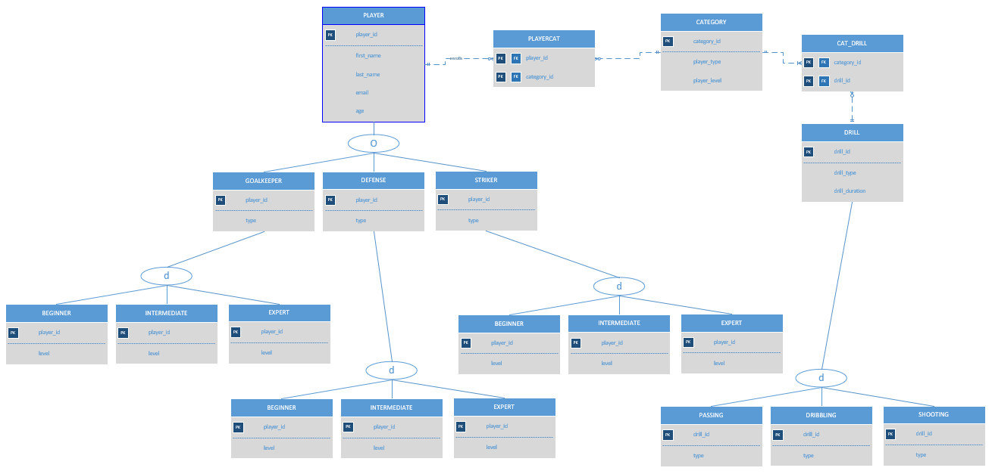
Figure 01: ERD from Assignment 04

Modification:
- I edited the entity name ‘BEGINNER’, ‘INTERMEDIATE’, ‘EXPERT’ as it seems like confusing for me when I am creating this subclass under their parent classes.
- I did not create ‘PASSING’, ‘DRIBBLING’ AND ‘SHOOTING’ entities as they inherit the same attribute from their parent class ‘DRILL’.
- I preferred to use all upper case in command and table name.

Procedure:

- Command to create PLAYER entity:
(For this table I forgot to write my name in PUTTY under the screenshot, I discover it later. But doing it so, I need to go through my full database from the very beginning. That’s why I skipped my name only for this entity)
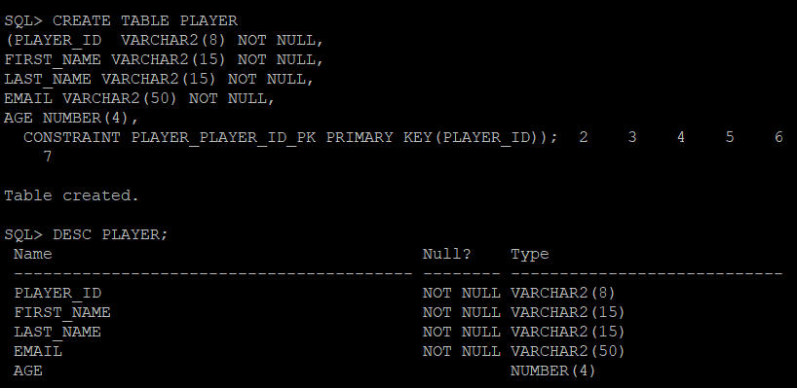
- Command to create GOALKEEPER entity:
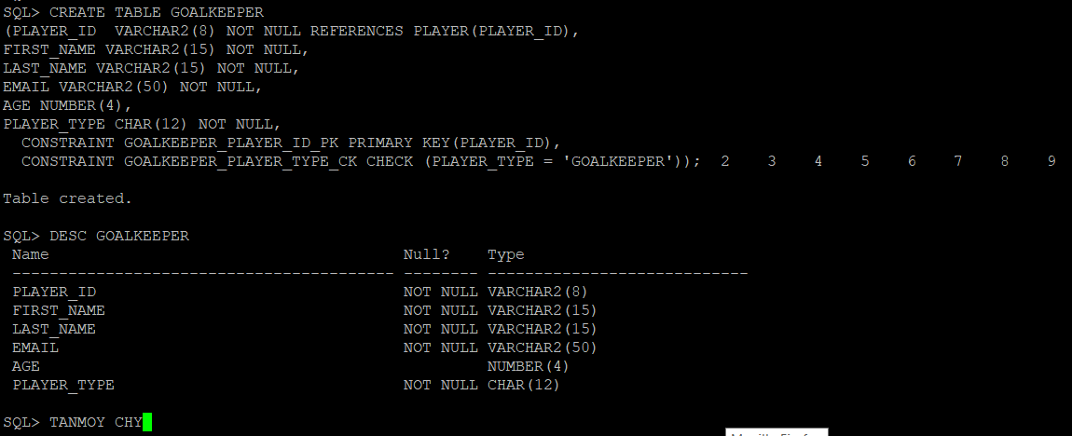
- Command to create GOALKEEPER_BEGINNER entity:
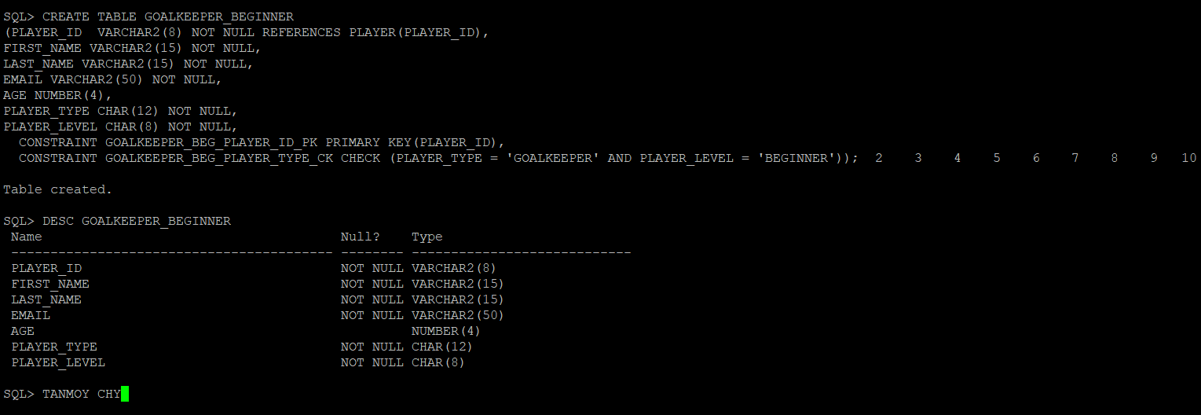

- Command to create GOALKEEPER_INTERMEDIATE entity:
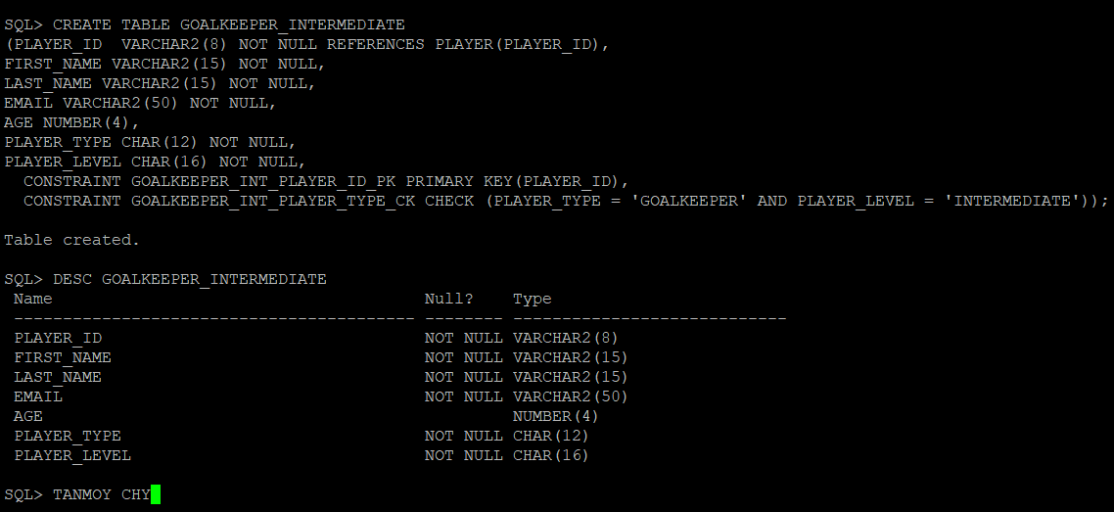
- Command to create GOALKEEPER_EXPERT entity:
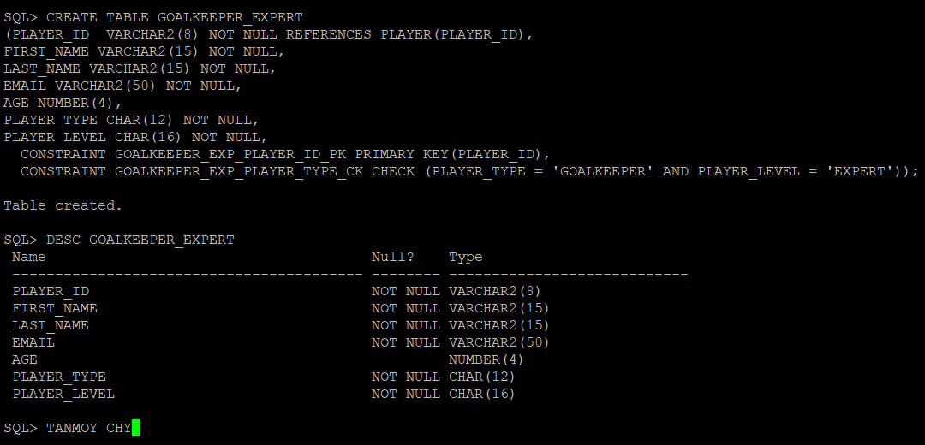

- Command to create DEFENSE entity:
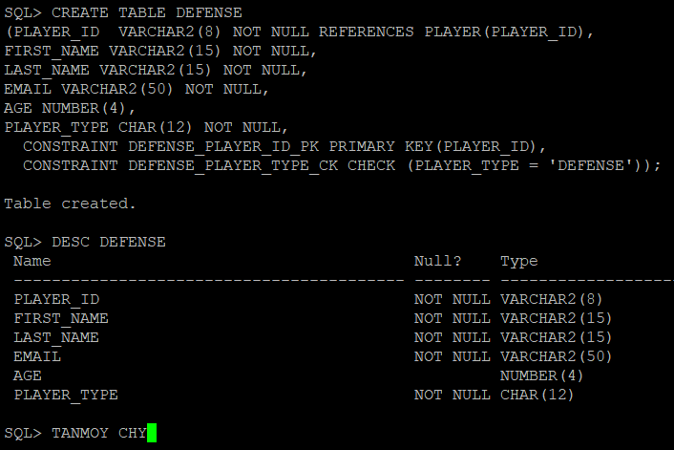
- Command to create DEFENSE _BEGINNER entity:
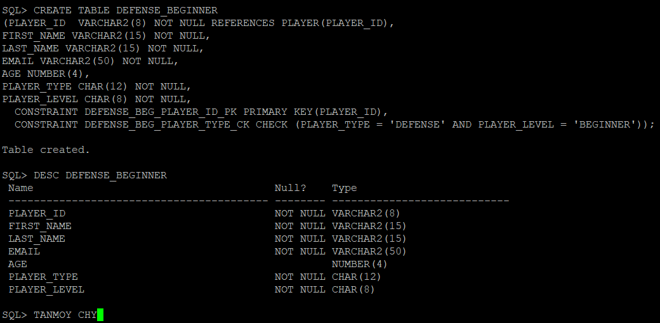

- Command to create DEFENSE _INTERMEDIATE entity:
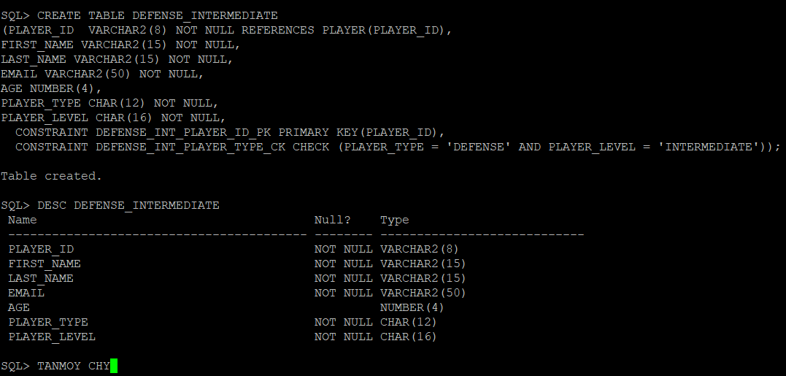
- Command to create DEFENSE _EXPERT entity:
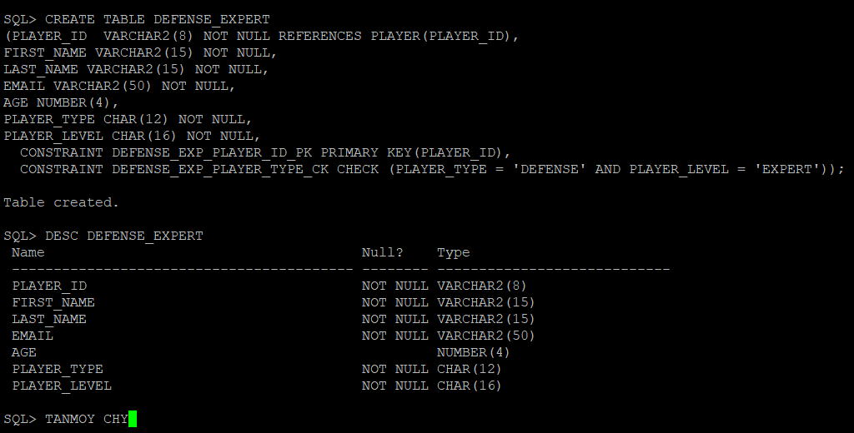

- Command to create STRIKER entity:
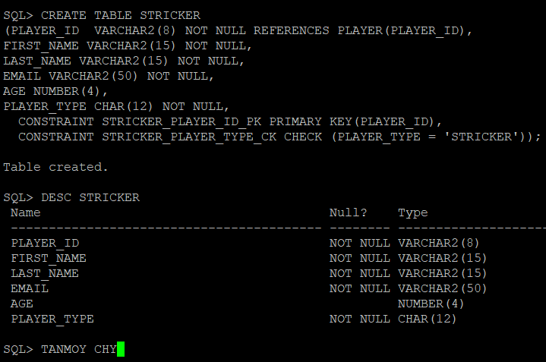
- Command to create STRIKER _BEGINNER entity:
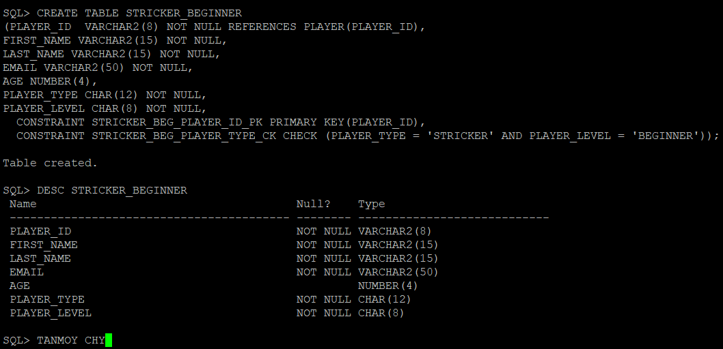

- Command to create STRIKER _INTERMEDIATE entity:
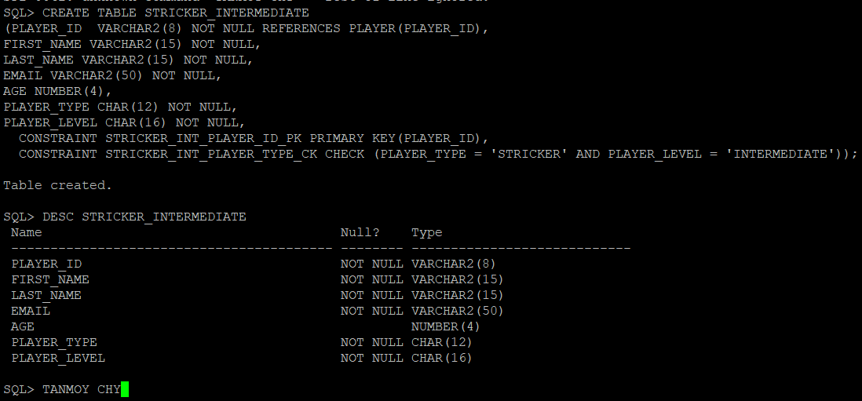
- Command to create STRIKER _EXPERT entity:
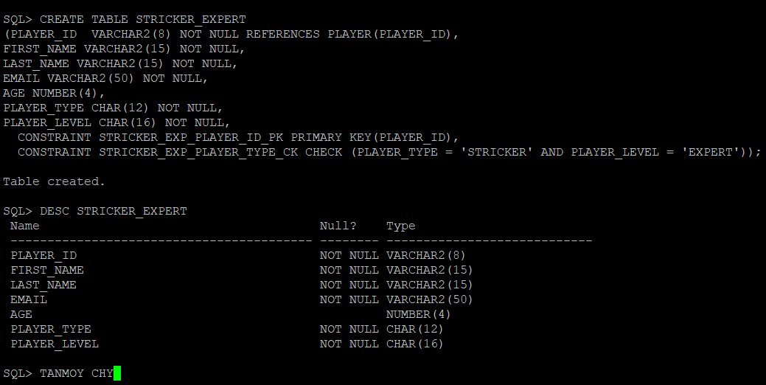

- Command to create CATEGORY entity
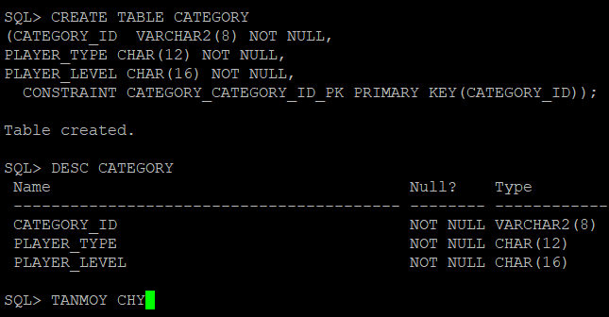
- Command to create PLAYERCAT entity
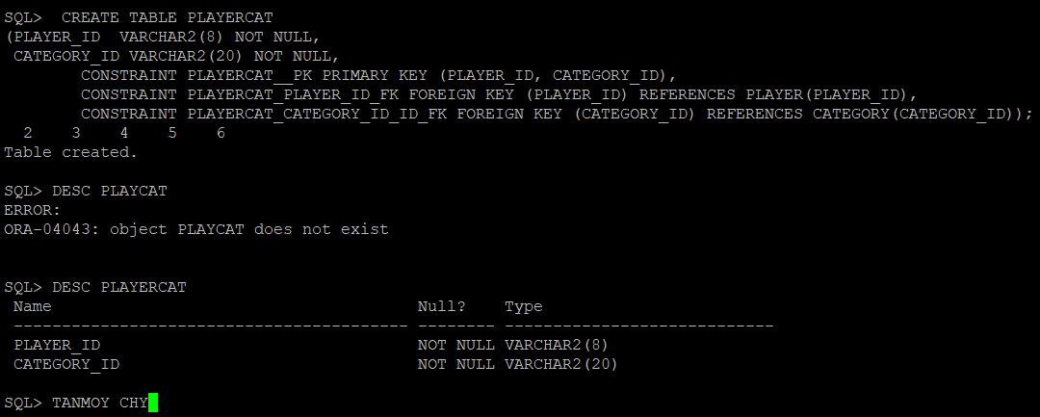
- Command to create DRILL entity
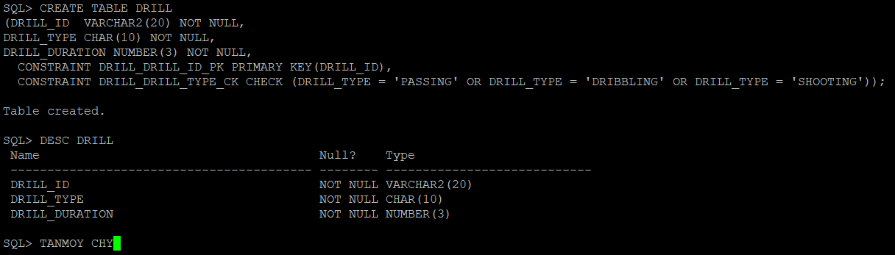

- Command to create CAT_DRILL entity
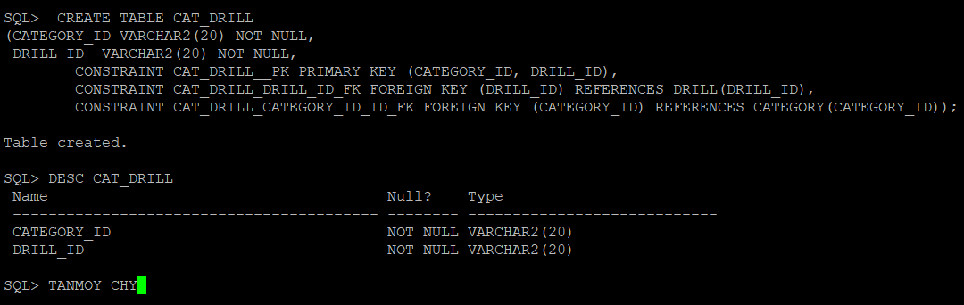

References
Casteel, J. (2016). Database system concepts and architecture in M. J. Horton, Oracle® 12c: SQL : Cengage Learning.
Retried from https://dba.stackexchange.com/questions/36573/how-to-model-inheritance-of-two-tables-mysql?utm_medium=organic&utm_source=google_rich_qa&utm_campaign=google_rich_qa

